*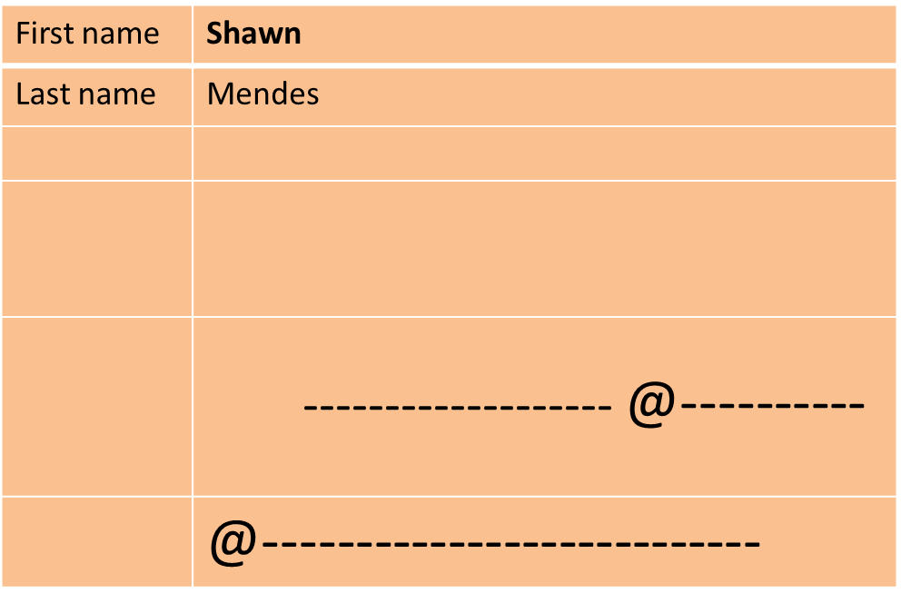WEEK 2 – HOMEWORK* ENGLISH I

Complete the chart with information of your favorite famous person.

Name:_____________________________________________class:________________